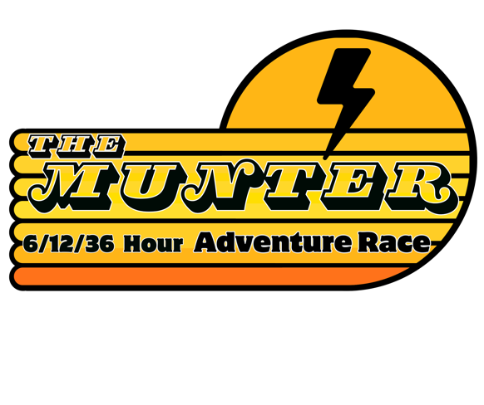
6 HOUR:

Greetings racers!
Hope your training and preparation has been going well for the 2025 Marokopa Munter Taranaki Edition 6 Hour Adventure Race!!
The course is sure to provide a fun playground for all teams and no doubt include some good old fashioned hills, bush, mud and views. Please read and share with the rest of your team…

Start line details will be posted online in the afternoon of Friday 24th October. The race location is an approximately 30 minute drive from Stratford/ 60 mins from New Plymouth.

As the 6 Hour race is unsupported, teams need to take all gear with them for the entire race. There will be water and toilets available at the Race Base, and will be possibilities (depending on strategy) to return to the base during the race.

6 Hour teams do not need to bring a PLB, sleeping bag or tent fly.

The race will finish back at the Race Base and all teams need to be back at the finish by 4:00pm. There will be a prize giving and sausage sizzle for all the 6 Hour racers at the completion of the race.

You will be racing in a wide variety of terrain- some of which is isolated and technically challenging- please come prepared with everything on the compulsory gear list and include those extra things you know can make racing more successful (like Gurney Goo or the slightly heavier Gore-Tex jacket, not GPS’s!)
Make sure your bike is functioning well- especially the brakes!

Matt, Nev, Mark, Mike and crew.

